Anatomy of an IMU

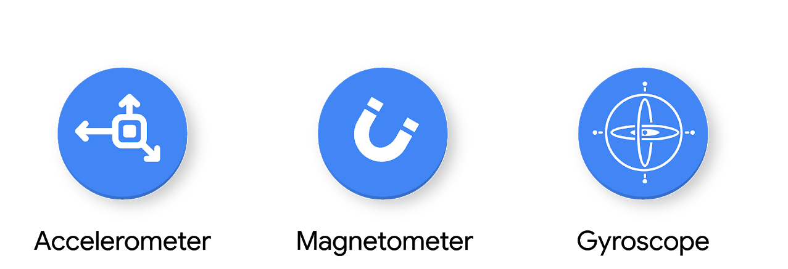

An inertial measurement unit (IMU) is a system composed of sensors that relay information about a device’s movement, such as accelerometers, gyroscopes, and magnetometers. In concert, each of the sensors provides a detailed account of a device’s instantaneous motion, orientation, and acceleration, which are often used for navigational and stabilizing purposes in vehicles and aircraft as part of electronic feedback control systems. We will be using it for our Magic Wand application. The Arduino Nano 33 BLE sense has a 9-axis IMU.

More recently, applications of the IMU to wearable devices have been stimulated by the quantified self-movement. The data generated from IMU’s can be used for machine learning purposes in classifying different types of actions associated with a device. For example, by attaching an IMU to a specific body part, such as an arm, it may be possible to discern different gestures purely from time-series information, such as waving, shaking hands, or typing on a keyboard. This makes the IMU particularly useful for embedded machine learning applications that are gesture-activated, such as lighting up your phone screen when picking it up, when checking the time on a smartwatch, or even fall detection.

**Structure of an IMU**

An IMU consists of at least two of the following sensors: an accelerometer, a gyroscope, and a magnetometer. In principle, these devices can be designed to provide single- or multi-axis measurements, but most offer multi-axis measurements to provide an accurate set of information associated with the position and orientation of a device in three-dimensional space. The importance of the IMU for sensing applications is highlighted by our Arduino Nano BLE Sense, which comes packaged with a built-in 9-axis IMU.

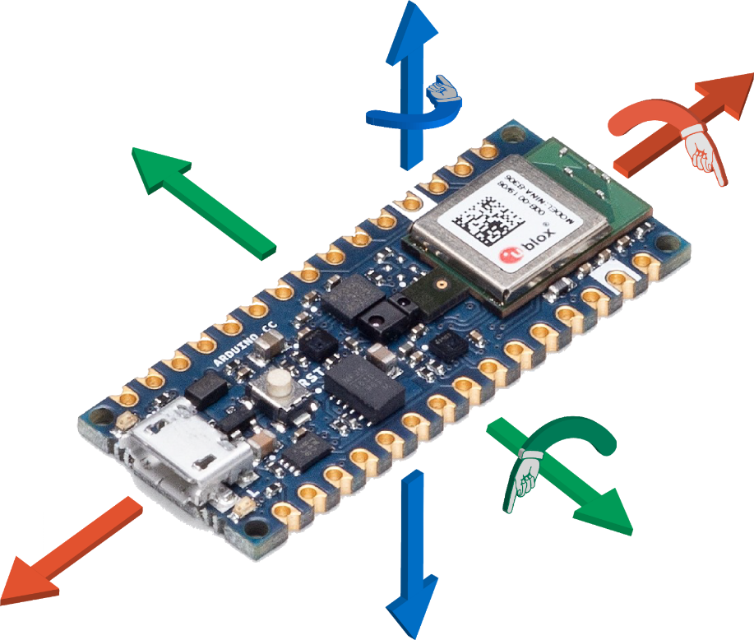

The three sensors that constitute an IMU afford for the following capabilities:

**Accelerometer.** Measures changes in velocity (acceleration) and position (velocity), as well as absolute orientation. The accelerometer is the device in tablets and smartphones which ensures the image on-screen remains upright regardless of orientation. By itself, the accelerometer provides information about the linear and rotational X-, Y-, and Z- directions. The accelerometer allows the 3-axis of motion to be captured. An onboard accelerometer is modeled as a micromechanical damped mass-spring system, wherein the compression or extension of the mass-spring system can be mathematically related to an object’s acceleration.

**Magnetometer.** Establishes cardinal direction (directional heading). A simple example of a magnetometer is a compass, which is used to measure the direction of the Earth’s magnetic field. Smaller versions called microelectromechanical magnetic field sensors can be incorporated into integrated circuits, allowing them to be combined with other sensors as part of an IMU. The magnetometer measures orientation to magnetic north on the X, Y, and Z axes. Together with the accelerometer, the 6 degrees-of-freedom of a system can be accounted for, which fully describes the kinematics of a system. Oftentimes, magnetometers work via the [Hall effect](https://en.wikipedia.org/wiki/Hall_effect#:~:text=The%20Hall%20effect%20is%20the,by%20Edwin%20Hall%20in%201879.), which involves the creation of a potential difference across a conductor as a result of a perpendicular applied magnetic field.

**Gyroscope.** Measures changes in orientation (rotation) and rotational velocity. Microelectromechanical gyroscopes, often called gyro meters, are present in many consumer electronics such as gaming controllers. A gyroscope provides information about the rotational X- (roll), Y- (pitch), and Z- (yaw) directions. The 6 degree-of-freedom system created by combining a magnetometer and accelerometer suffers from several shortcomings, such as the sensitivity of magnetometers to time-varying magnetic disturbances, and the corruption of accelerometer readings due to the presence of linear acceleration distorting the Earth gravity vector.

To alleviate these shortcomings, a 3-axis gyroscope can be added, creating a 9 degree-of-freedom, or “gyro-stabilized” system. The gyroscope provides the system with an independent measurement of instantaneous rotation speed, complementing the original 6 degree-of-freedom system. The gyroscope works by the conservation of angular momentum; a spinning wheel or disc rotates at high speed, while the spin axis is freely allowed to rotate and assume any orientation. The inertia of the spinning wheel allows it to remain unperturbed in the same direction during tilting or rotation, allowing rotational information to be discerned.

**Next Steps**

In the following sections, we will focus on obtaining time-series information from the onboard IMU, and subsequently, use this information to train a machine learning model capable of detecting specific actions of a magic wand.